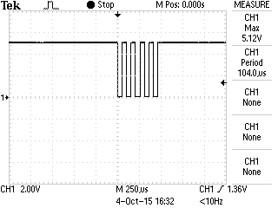

**Baudrate:**

104/2 = 52 µs

Thus baudrate = 1/52 = 19230.76 [bps]

**Voltage level**:

Voltsmax = 5.12 [V]